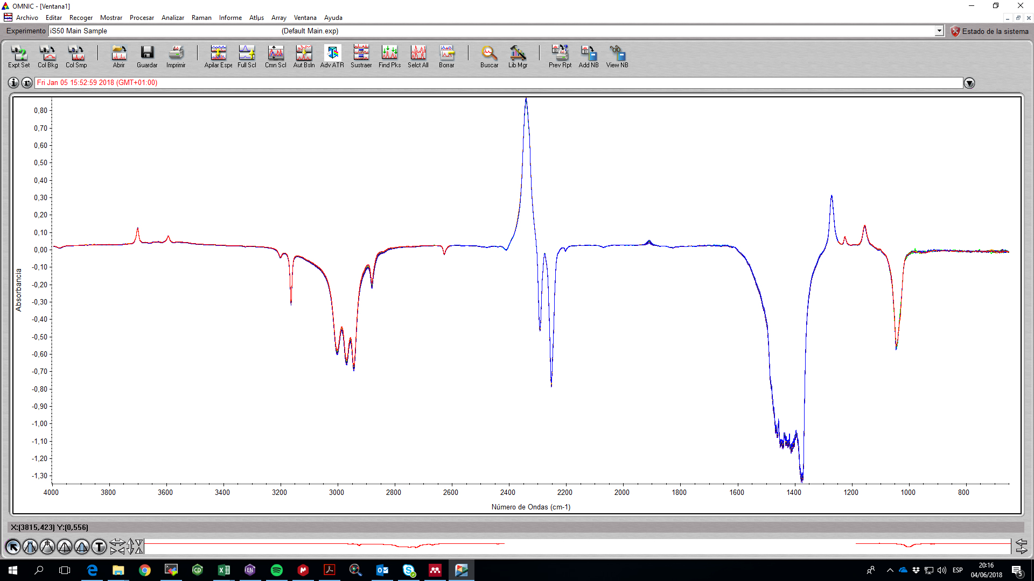The final result consists in the representation of the different spectra in a single figure in which the x axis is wave number (first column of the file) and the y value is absorbance (second column of the file).